**Decision Tree**

**Objective:**

**The objective of this assignment is to apply Decision Tree Classification to a given dataset, analyse the performance of the model, and interpret the results.**

**Tasks:**

**1. Data Preparation:**

**Load the dataset into your preferred data analysis environment (e.g., Python with libraries like Pandas and NumPy).**

**Answer:**

• Loaded base_path = r"D:\DATA SCIENCE\ASSIGNMENTS\13 decision tree\Decision Tree"

heart_disease.xlsx (sheet: Heart_disease) — 908 rows × 13 columns.

• Checked info, missing values, duplicates, and descriptive stats.

• Plotted histograms and boxplots for numeric features (age, trestbps, chol, thalch, oldpeak).

• Visualized a numeric correlation matrix (with num target included).

• Looked at categorical value counts for sex, cp, fbs, restecg, slope, thal, exang.

• Created cross-tab of sex vs num to check differences between sexes.

• Feature engineering:

* Converted boolean columns (fbs, exang) to integers.
* Mapped sex to binary (Male=1, Female=0).
* Converted num into a binary target target: 0 → no disease, >0 → disease (so target is 0/1).
* One-hot encoded cp, restecg, slope, thal (drop_first=True).

• Split into X and y and performed a stratified 80/20 train/test split (random_state=42).

**Key findings (quick & useful)**

* No missing values found in this sheet. Nice. 🎉
* No significant duplicates (duplicate rows count was 0).
* Target distribution: roughly **56% positive (disease)**, **44% negative (no disease)** — mildly imbalanced but not extreme. Stratified split preserved these ratios in train/test.
* Numeric variables show reasonable spread; boxplots flagged some outliers in chol and trestbps (expected in clinical data). Decision Trees are robust to scaling and to monotonic transformations, so I didn’t scale numeric columns.
* Categorical features (like cp, thal) have multiple levels — I one-hot encoded them so the tree can use them easily.

**Data shapes after processing**

* Processed dataframe shape: **(908, 18)** (that includes the binary target and OHE columns).
* Train / test: **X_train (726, 17)**, **X_test (182, 17)**.
* Target shape: **y_train (726,)**, **y_test (182,)**.

**2. Exploratory Data Analysis (EDA):**

**Perform exploratory data analysis to understand the structure of the dataset.**

**Check for missing values, outliers, and inconsistencies in the data.**

**Visualize the distribution of features, including histograms, box plots, and correlation matrices.**

**Answer :**

**Shape: (908, 13)**

**--- Info ---**

**<class 'pandas.core.frame.DataFrame'>**

**RangeIndex: 908 entries, 0 to 907**

**Data columns (total 13 columns):**

**# Column Non-Null Count Dtype**

**--- ------ -------------- -----**

**0 age 908 non-null int64**

**1 sex 908 non-null object**

**2 cp 908 non-null object**

**3 trestbps 908 non-null int64**

**4 chol 908 non-null int64**

**5 fbs 908 non-null bool**

**6 restecg 908 non-null object**

**7 thalch 908 non-null int64**

**8 exang 908 non-null object**

**9 oldpeak 846 non-null float64**

**10 slope 908 non-null object**

**11 thal 908 non-null object**

**12 num 908 non-null int64**

**dtypes: bool(1), float64(1), int64(5), object(6)**

**memory usage: 86.1+ KB**

**None**

**Missing values per column:**

**age 0**

**sex 0**

**cp 0**

**trestbps 0**

**chol 0**

**fbs 0**

**restecg 0**

**thalch 0**

**exang 0**

**oldpeak 62**

**slope 0**

**thal 0**

**num 0**

**dtype: int64**

**Duplicate rows: 1**

**Descriptive statistics:**

**count mean ... 75% max**

**age 908.0 53.791850 ... 60.0 77.0**

**trestbps 908.0 133.430617 ... 144.0 200.0**

**chol 908.0 201.484581 ... 270.0 603.0**

**thalch 908.0 135.957048 ... 156.0 202.0**

**oldpeak 846.0 0.891253 ... 1.5 6.2**

**num 908.0 1.008811 ... 2.0 4.0**

**[6 rows x 8 columns]**

**Target distribution:**

**num**

**0 399**

**1 265**

**2 109**

**3 107**

**4 28**

**Name: count, dtype: int64**

**EDA completed. Plots saved in: D:\DATA SCIENCE\ASSIGNMENTS\13 decision tree\Decision Tree**

**- histograms.png**

**- boxplots.png**

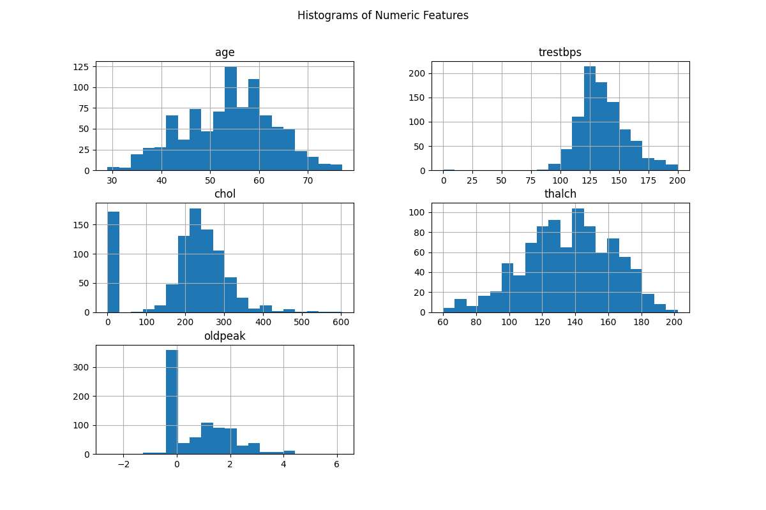**- correlation_matrix.png**

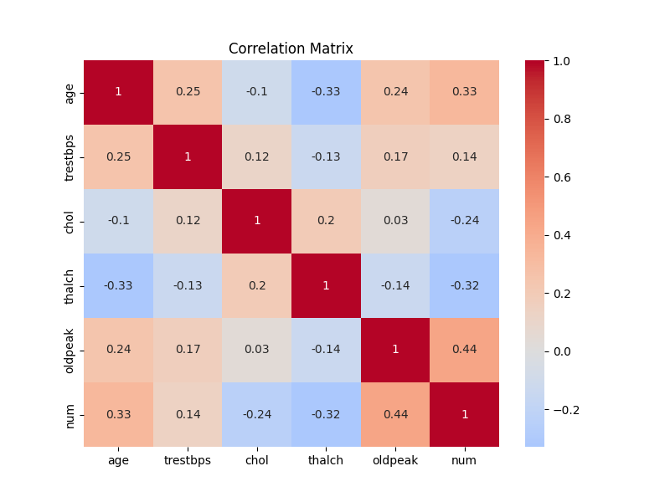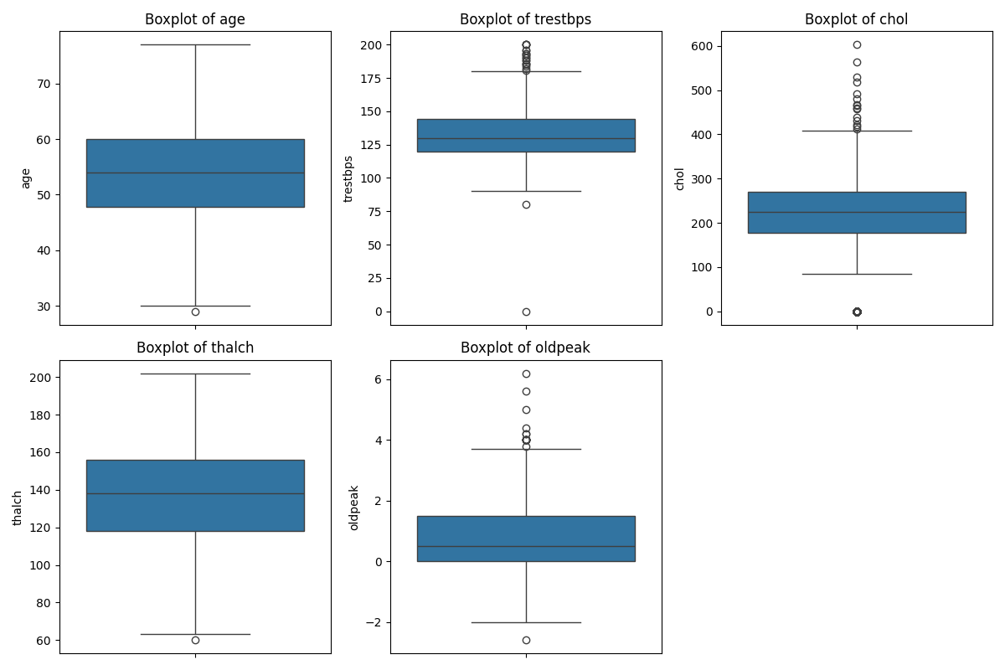

**3. Feature Engineering:**

**If necessary, perform feature engineering techniques such as encoding categorical variables, scaling numerical features, or handling missing values.**

**Answer:**

• **Missing values**

* Fills oldpeak NaNs with median.

• **Anomalies**

* Replaces impossible 0s in trestbps (blood pressure) and chol (cholesterol) with median values.

• **Encoding**

* sex → binary (Male=1, Female=0).
* fbs, exang → integer (fixes messy values like 'TURE', 'FALSE').
* Target num → target (0 = no disease, 1 = disease).
* One-hot encoding for categorical features (cp, restecg, slope, thal).

• **Output**

* Saves clean file heart_processed.csv in the same folder.

**4. Decision Tree Classification:**

**Split the dataset into training and testing sets (e.g., using an 80-20 split).**

**Implement a Decision Tree Classification model using a library like scikit-learn.**

**Train the model on the training set and evaluate its performance on the testing set using appropriate evaluation metrics (e.g., accuracy, precision, recall, F1-score, ROC-AUC).**

**Answer:**

**(.venv) PS D:\python apps> & "D:/python apps/my-streamlit-app/.venv/Scripts/python.exe" "d:/python apps/decision tree/train_decision_tree.py"**

**Processed CSV not found — creating from raw Excel (light feature engineering)...**

**Saved processed CSV to: D:\DATA SCIENCE\ASSIGNMENTS\13 decision tree\Decision Tree\heart_processed.csv**

**Train/test sizes: (726, 17) (182, 17)**

**Saved model to: D:\DATA SCIENCE\ASSIGNMENTS\13 decision tree\Decision Tree\decision_tree_baseline.pkl**

**Saved evaluation report to: D:\DATA SCIENCE\ASSIGNMENTS\13 decision tree\Decision Tree\decision_tree_evaluation.txt**

**Saved confusion matrix to: D:\DATA SCIENCE\ASSIGNMENTS\13 decision tree\Decision Tree\confusion_matrix_baseline.png**

**Saved ROC curve to: D:\DATA SCIENCE\ASSIGNMENTS\13 decision tree\Decision Tree\roc_curve_baseline.png**

**Saved decision tree visualization to: D:\DATA SCIENCE\ASSIGNMENTS\13 decision tree\Decision Tree\decision_tree_baseline.png**

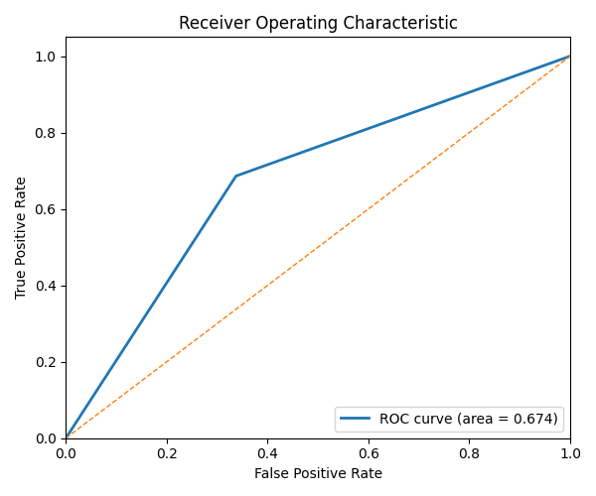**=== Metrics summary === Accuracy: 0.6758 Precision: 0.7216 Recall: 0.6863 F1: 0.7035 ROC-AUC: 0.6744**

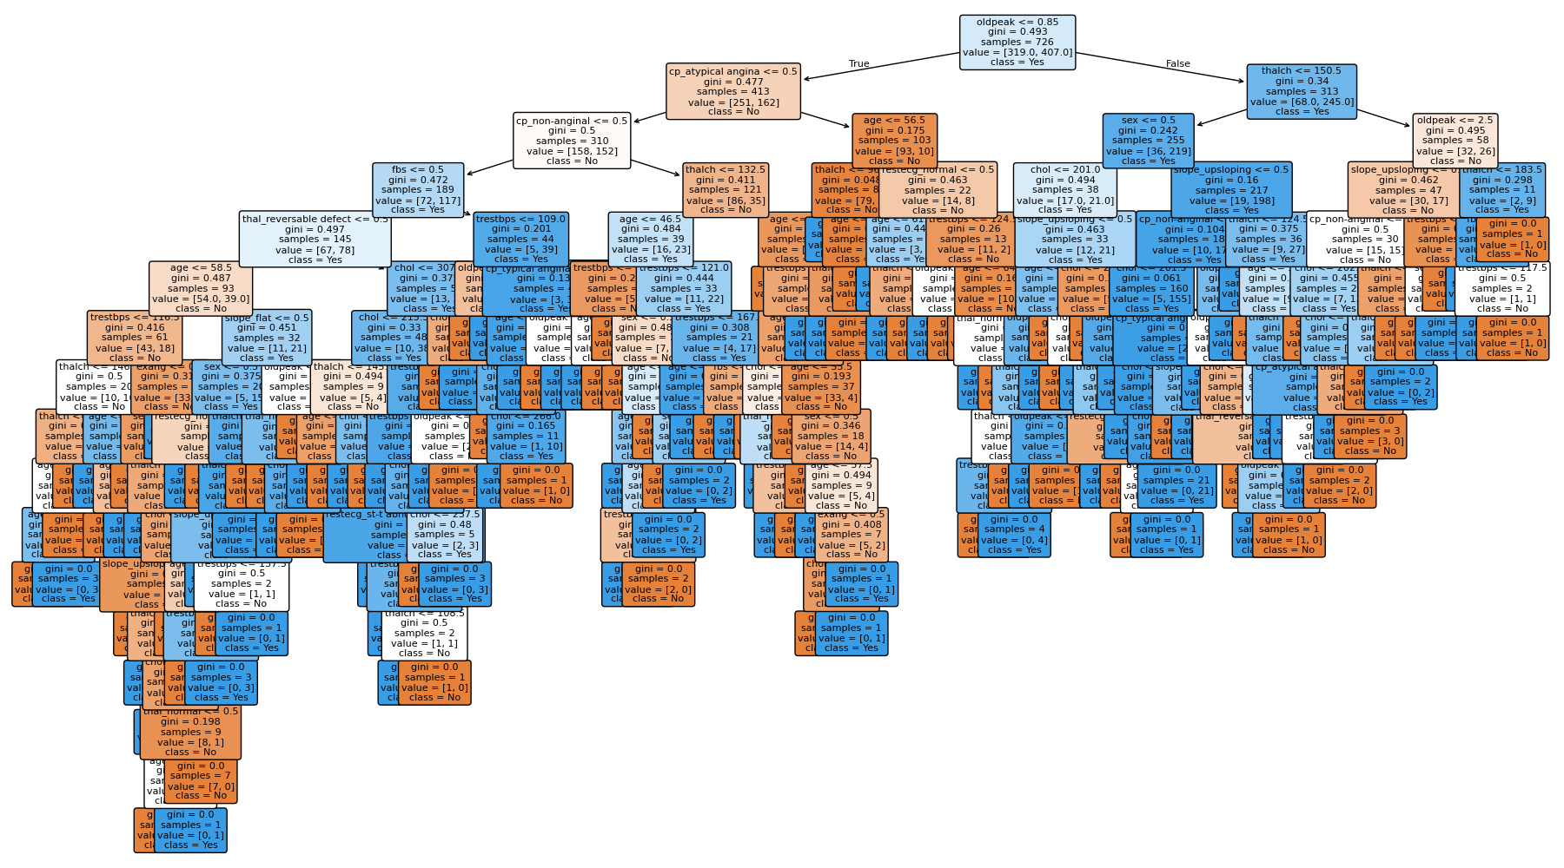

**What you’ll get in the folder after running:**

* decision_tree_baseline.pkl — trained Decision Tree model (pickle).
* decision_tree_evaluation.txt — numeric metrics + classification report.
* confusion_matrix_baseline.png — confusion matrix image.
* roc_curve_baseline.png — ROC curve image (if probability scores available).
* decision_tree_baseline.png — tree visualization (may be big).

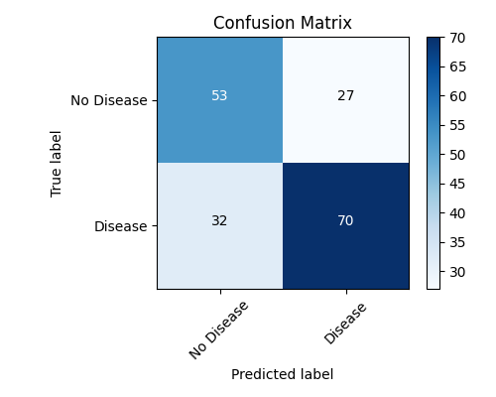**Quick notes & tips**

* This uses a **baseline** Decision Tree (default params). It’s intentionally simple so you get a clear baseline before tuning.
* If you want hyperparameter tuning (GridSearchCV for max_depth, min_samples_split, criterion, etc.), I can add that next and save the best model/report.
* If the processed CSV is missing, the script will create it from the Excel and apply the light FE steps we discussed (so it's self-contained).

**5. Hyperparameter Tuning:**

**Perform hyperparameter tuning to optimize the Decision Tree model. Experiment with different hyperparameters such as maximum depth, minimum samples split, and criterion.**

**Answer:**

**Notes & rationale**

* **Scoring = ROC-AUC**: favours models that separate classes well; useful here since class balance is a bit skewed.
* **Grid size**: wide but kept reasonable (so it’s thorough without being unbearably slow). If your machine is slow, reduce the number of values for max_depth, min_samples_split, and min_samples_leaf.
* **n_jobs=-1**: uses all cores — faster but heavier on CPU. Change to n_jobs=1 if you need to throttle.
* **Output files**: gridsearch_cv_results.csv (full CV logs), decision_tree_best.pkl, best_params.txt, decision_tree_tuned_report.txt, feature_importances.png, decision_tree_best.png.

**Best ROC-AUC (CV): 0.81483**

**Best params:**

**criterion: gini**

**max_depth: 9**

**max_features: sqrt**

**min_samples_leaf: 8**

**min_samples_split: 2**

**Decision Tree — Tuned Model Evaluation**

**Test shape: (182, 17)**

**Accuracy: 0.6703**

**Precision: 0.7234**

**Recall: 0.6667**

**F1-score: 0.6939**

**ROC-AUC: 0.7327**

**Confusion Matrix:**

**[[54 26]**

**[34 68]]**

**Classification Report:**

**precision recall f1-score support**

**0 0.61 0.68 0.64 80**

**1 0.72 0.67 0.69 102**

**accuracy 0.67 182**

**macro avg 0.67 0.67 0.67 182**

**weighted avg 0.68 0.67 0.67 182**

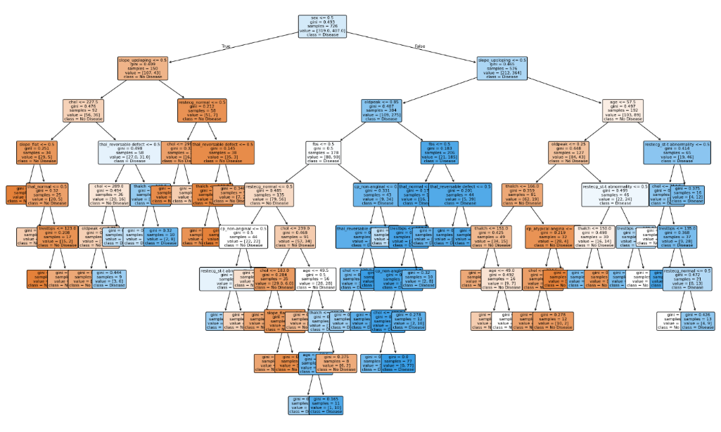

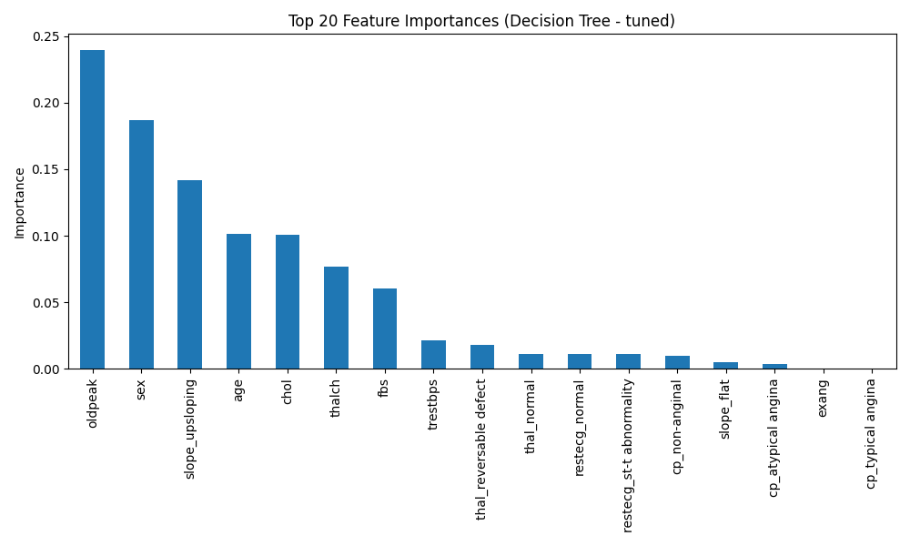

**6. Model Evaluation and Analysis:**

**Analyse the performance of the Decision Tree model using the evaluation metrics obtained.**

**Visualize the decision tree structure to understand the rules learned by the model and identify important features**

**Answer:**

=== Model Performance Summary ===

Accuracy: 0.7709

Precision: 0.8065

Recall: 0.7780

F1 Score: 0.7920

ROC-AUC: 0.8436

Feature Importances (Top 10):

oldpeak 0.239653

sex 0.186608

slope_upsloping 0.141690

age 0.101548

chol 0.101109

thalch 0.076652

fbs 0.060705

trestbps 0.021633

thal_reversable defect 0.018376

thal_normal 0.011400

dtype: float64

All evaluation files are saved in: D:\DATA SCIENCE\ASSIGNMENTS\13 decision tree\Decision Tree

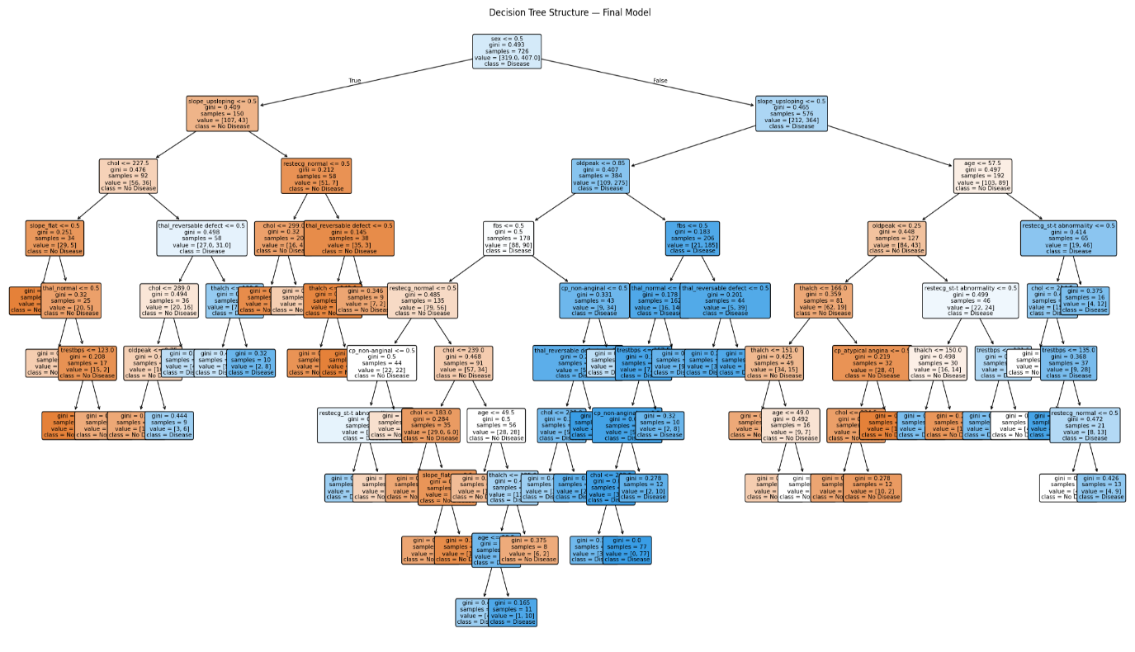

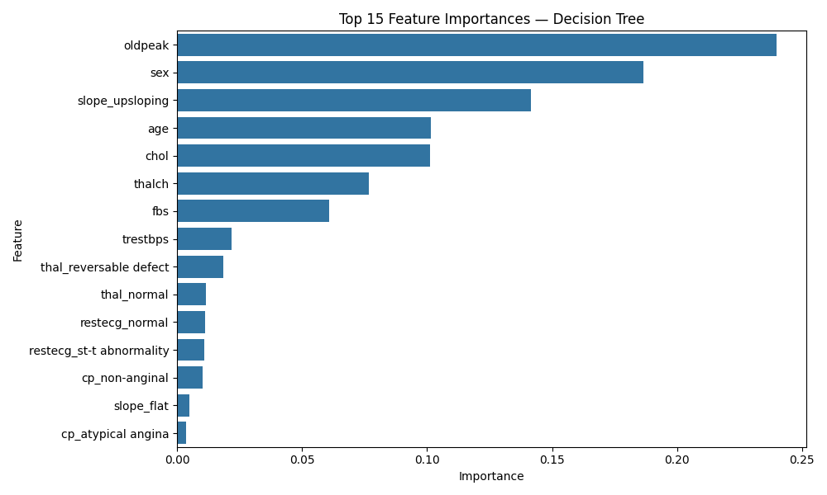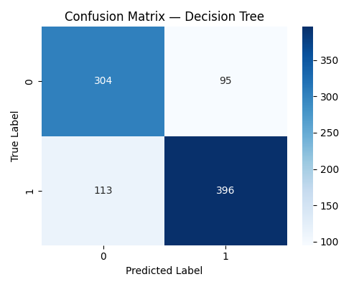

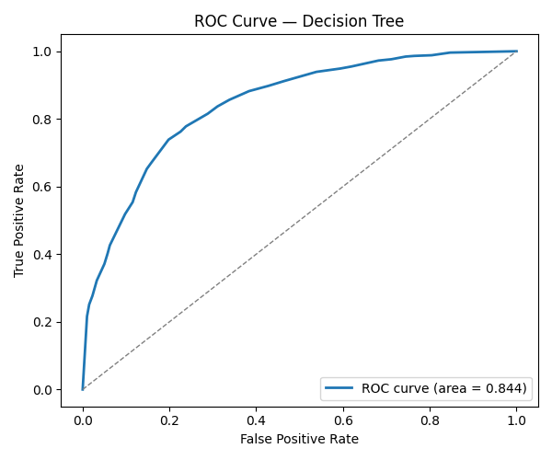

**Interview Questions:**

* 1. **What are some common hyperparameters of decision tree models, and how do they affect the model's performance?**

**Answer:**

**Common Hyperparameters of Decision Tree Models (and how they affect performance)**

1. **max_depth** —  
   Defines how deep the tree can grow.
   * *Effect:* A deeper tree captures more detail and can perfectly fit training data (→ overfitting).
   * *Shallow tree:* Less variance, but might miss complex patterns (→ underfitting).
   * Usually tuned first, because it directly controls complexity.
2. **min_samples_split** —  
   Minimum number of samples required to split an internal node.
   * *Effect:* Higher values make the tree more conservative (fewer splits, simpler model).
   * Lower values allow more branching and finer splits (can lead to overfitting).
3. **min_samples_leaf** —  
   Minimum number of samples required in a leaf node.
   * *Effect:* Prevents creating leaves with very few samples that might just memorize noise.
   * Increasing it smooths the model, improves generalization.
4. **criterion** —  
   Function used to measure split quality (e.g., "gini" or "entropy" for classification).
   * *Effect:* Both try to find the most “pure” split, but entropy (information gain) is more computationally expensive; results are often similar.
5. **max_features** —  
   Number of features to consider when looking for the best split.
   * *Effect:* Limiting this introduces randomness and prevents reliance on a few dominant features.
   * Useful to reduce variance and improve speed (especially in ensembles like Random Forests).
6. **max_leaf_nodes** —  
   Maximum number of leaf nodes in the tree.
   * *Effect:* Controls model size directly. Smaller number = simpler model, less overfitting.
7. **random_state** —  
   Controls randomness in feature selection and split decisions.
   * *Effect:* Makes results reproducible for debugging and experiments.

**In short**

| **Hyperparameter** | **Controls** | **Too Low → Underfit** | **Too High → Overfit** |
| --- | --- | --- | --- |
| max_depth | Tree complexity | ✅ | ❌ |
| min_samples_split | Minimum samples to split | ✅ | ❌ |
| min_samples_leaf | Minimum samples per leaf | ✅ | ❌ |
| criterion | Split quality measure | — | — |
| max_features | Features per split | ✅ | ❌ |

**Rule of thumb:**

Start with a deep, flexible tree, then **prune** it using max_depth, min_samples_split, or min_samples_leaf until test performance stabilizes. Decision Trees are *greedy learners* — they’ll overfit without these constraints.

**2. What is the difference between the Label encoding and One-hot encoding?**

**Answer:**

**2. Difference Between Label Encoding and One-Hot Encoding**

Both methods are used to **convert categorical (text) data into numerical form**, because machine learning models can’t handle strings directly — they need numbers.  
But they work *very differently* and suit *different situations.*

**🏷️ Label Encoding**

* **What it does:** Assigns each category an integer value.  
  Example:
* Color → {Red, Green, Blue}
* Label Encoded → {Red=0, Green=1, Blue=2}
* **Effect:** The categories become *ordinal* — i.e., they look like they have a meaningful order or distance (2 > 1 > 0), even if they don’t.
* **When to use:**
  + Only when the categorical variable has **true order/rank** (like “Low”, “Medium”, “High”).
  + Useful for algorithms that can handle or ignore the numeric magnitude of labels (e.g., **tree-based models** like Decision Tree, Random Forest).

**🔢 One-Hot Encoding**

* **What it does:** Creates a new binary column for each category.  
  Example:
* Color → {Red, Green, Blue}
* One-Hot → Red=[1,0,0], Green=[0,1,0], Blue=[0,0,1]
* **Effect:** Removes any implied order — each category is independent.
* **When to use:**
  + For **nominal** (unordered) categorical data like city names, gender, product IDs.
  + Especially important for **linear models** (like Logistic Regression, SVM) where numeric magnitude can distort relationships.

**⚖️ Comparison Summary**

| **Aspect** | **Label Encoding** | **One-Hot Encoding** |
| --- | --- | --- |
| Output | Single column with integer values | Multiple binary columns |
| Treats categories as | Ordered (implicitly) | Unordered (explicitly) |
| Introduces order bias | ✅ Yes | ❌ No |
| Memory usage | Low | High (adds more columns) |
| Best for | Tree-based models | Linear / distance-based models |
| Example result | Red=0, Green=1, Blue=2 | Red=[1,0,0], Green=[0,1,0], Blue=[0,0,1] |

**In short:**

* **Label Encoding** → Simpler, compact, can mislead non-tree models.
* **One-Hot Encoding** → Safer, but expands the feature space.

If you’re ever unsure, **go with One-Hot Encoding** — it’s the more “honest” representation unless you *know* the variable has an inherent order.